ASSIGNMENT -5 (Kafka + Spark)

Sruthy Suji
23AD140
AI-DS C

1) Create a new topic - greentaxi-topic

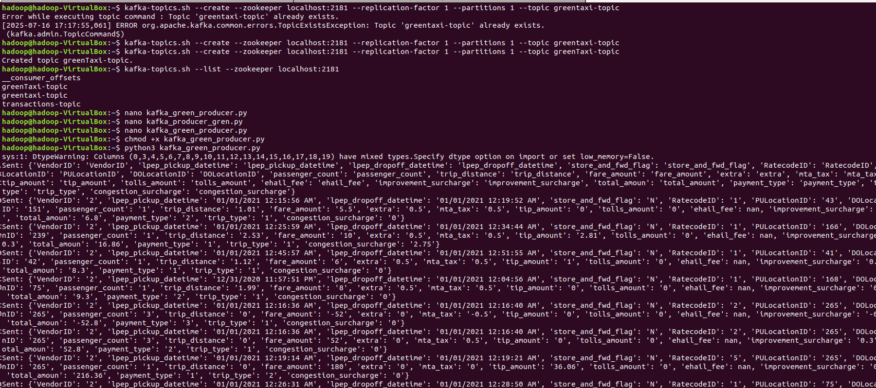

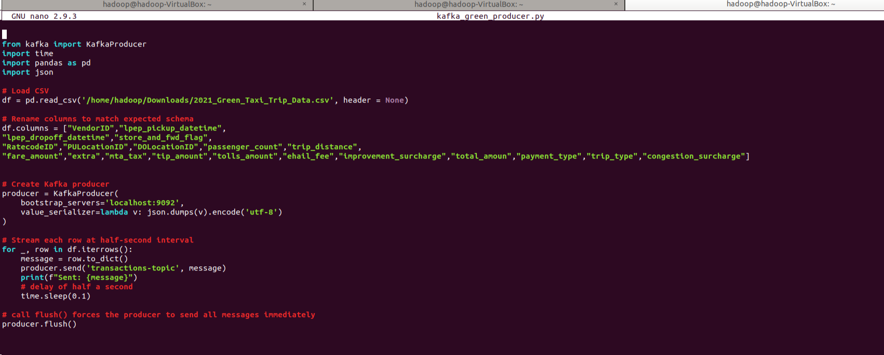
- Stream Data @ 0.1 Sec Interval using Kafka_Taxi_Producer.py

- Show Top 5 Trending Pickup Local - "PULocationID" [5] and Drop Location - "DOLocationID" [6]

